1, Format the TF card to 4096 as below,

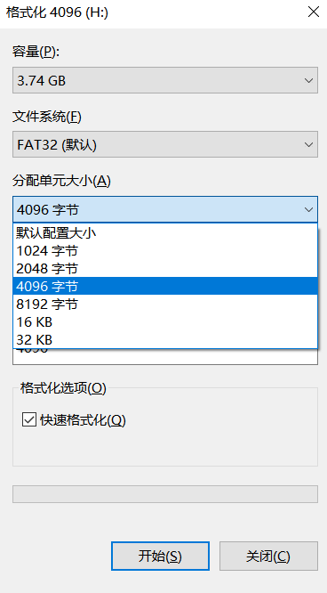

2, Insert the TF card into the computer, drag the file Robin_e3.bin (ATTENTION: ENSURE THE FILE NAME IS UNCHANGED, MUST BE Robin_e3.bin. Remove the used firmware files from the TF card, only the new firmware in the card,otherwise the new firmware file name will be changed automatically) into the root directory of the TF card, and note the file name cannot be modified and should be placed in the root directory;

3, Power off the printer and insert the TF card into the TF card slot on the printer base.

4, Power on the printer and wait for the firmware updating is finished.

Attention the order of 3 and 4 can not be reversed.

(a)signal for flashing successfully: the extruder light on and light off ten seconds later(the system spends around ten seconds to process the updating), then the display screen lights up accordingly.

(b)signal for flashing unsuccessfully: the extruder light on and light off immediately(the system does not process the updating at all), and the display screen lights up immediately.

5,the refreshing is completed.